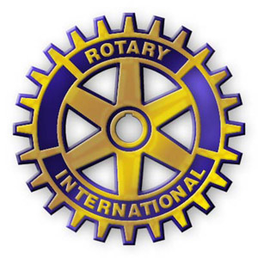
funding request form
ROTARY CLUB OF NORTH CONWAY
Completion of this form is required for your funding request to be considered.
Funding requests will be voted upon by the Rotary Club of North Conway Board of Directors at monthly board meetings. Meetings are held on the second Wednesday of each month. Funding applications may be submitted electronically to: rotaryclubofnorthconway@gmail.com or via mail by the first of the month to be voted upon at that month’s meeting.
Please also note, we do not fund operating costs for events and prefer to help with tangible requests that will assist an organization or cause.
Please mail form to:
Rotary Club of North Conway
P.O. Box 2034
North Conway, NH, 03860

Date of Submission:

Name of Organization:

Contact:

Phone number:

Email address:

Event Date:

If granted, check should be made payable to:

If granted, funds should be mailed to:

How will the North Conway Rotary be recognized as part of the event?

Please summarize event/program:

Total Event/Program Cost:

Funding Amount Requested:

Other Funding Sources:

Any other pertinent details:

Thank you from the North Conway Rotary Club!

